

**Course Title : Database Management System Lab**

**Project Name : Warehouse Management System**

**Submitted By**

Md: Sifat Hossen

ID: **41230100957**

Anamul Islam

ID: **41230100841**

**Submitted to**

Rumman Ahmed Prodhan

Lecturer, Department of CSE

Northern University Bangladesh

**Index**

|  |  |  |
| --- | --- | --- |
| **No.** | **Topic Name** | **Page No.** |
| **1** | **Information of the Database** | **3-4** |
| **2** | **Schema Diagram of the warehouse Management System** | **5** |
| **3** | **ER Diagram of the warehouse Management System** | **6** |
| **4** | **Insert data into tables** | **7-9** |
| **5** | **Running Query** | **10-16** |

**WAREHOUSE MANAGEMENT SYSTEM**

**The information which are going to be available in the database are given below:**

A Warehouse Management System (WMS) is a software application designed to support and optimize warehouse or distribution center management. It facilitates various functions, including inventory management, order fulfillment, shipping and receiving and many more feature within the warehouse.

**Table:** Warehouses

**Attributes:** warehouse_id, name, location

**Relations:**

1. Warehouses – warehouse_id – Inventory
2. Warehouses – warehouse_id – Transfers (as source_warehouse_id and destination_warehouse_id)
3. Warehouses – warehouse_id – Orders
4. Warehouses – warehouse_id – Supply_Orders

**Table:** Products

**Attributes:** product_id, name, category, price

**Relations:**

1. Products – product_id – Inventory
2. Products – product_id – Transfers
3. Products – product_id – Orders
4. Products – product_id – Supply_Orders

**Table:** Inventory

**Attributes:** inventory_id, warehouse_id product_id, quantity, last_updated, flight_name, flight_date, plane_name

**Relations:**

1. Inventory – warehouse_id – Warehouses
2. Inventory – product_id – Products

**Table:** Transfers

**Attributes:** transfer_id, source_warehouse_id, destination_warehouse_id, product_id, transfer_quantity,transfer_date,

**Relations:**

1. Transfers – source_warehouse_id – Warehouses
2. Transfers – destination_warehouse_id – Warehouses
3. Transfers – product_id – Products

**Table:** Suppliers

**Attributes:** supplier_id, supplier_name, contact_info,

**Relations:**

1. Suppliers – supplier_id – Supply_Orders

**Table:** Orders

**Attributes:** order_id, product_id, warehouse_id, order_quantity, order_date,delivery_date, customer_name, customer_contact,

**Relations:**

1. Orders – product_id – Products
2. Orders – warehouse_id – Warehouses

**Table:** Supply_Orders

**Attributes:** order_id, product_id, warehouse_id, order_quantity, order_date,delivery_date, customer_name, customer_contact,

**Relations:**

1. Supply_Orders – supplier_id – Suppliers
2. Supply_Orders – product_id – Products
3. Supply_Orders – warehouse_id – Warehouses

**Schema Diagram For WareHouse Management System**

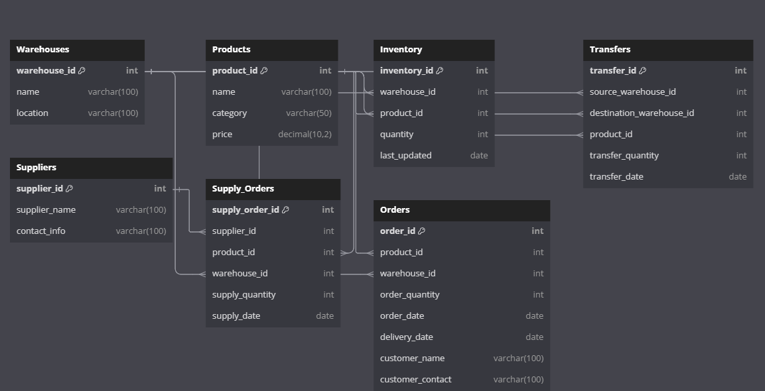

**ER Diagram For WareHouse Management System**

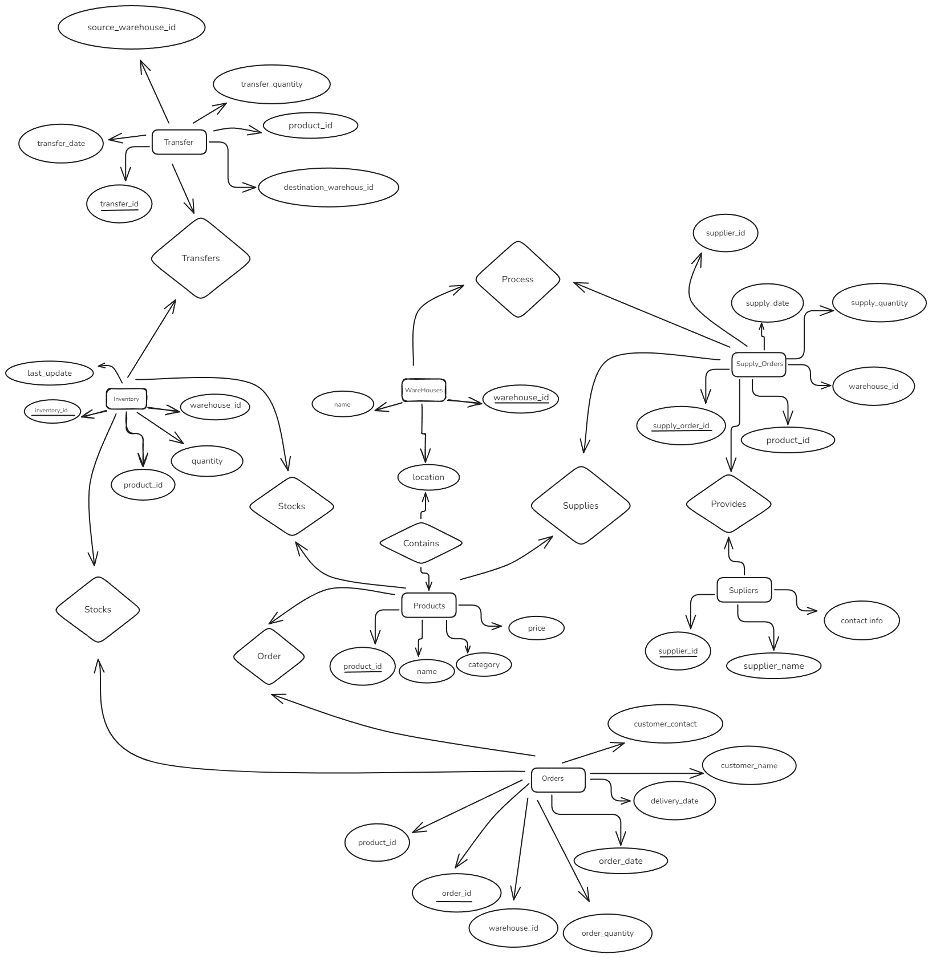

**Insert data into tables:**

**Table: Warehouses**

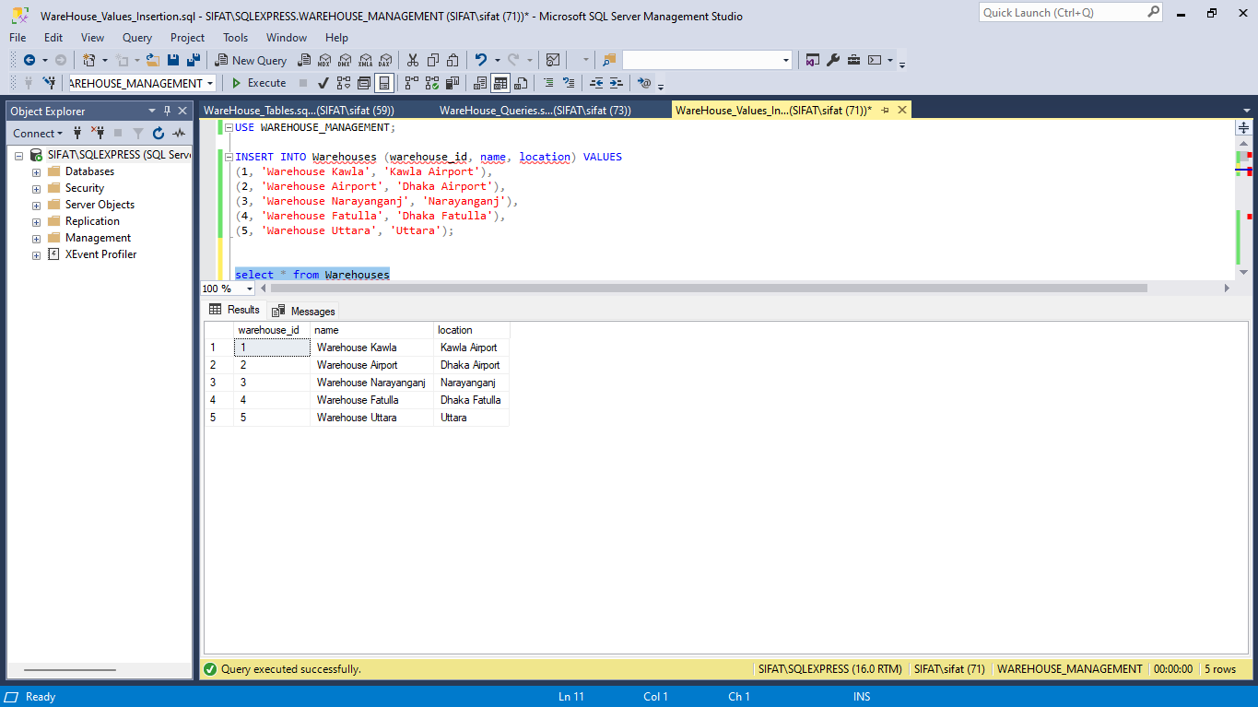

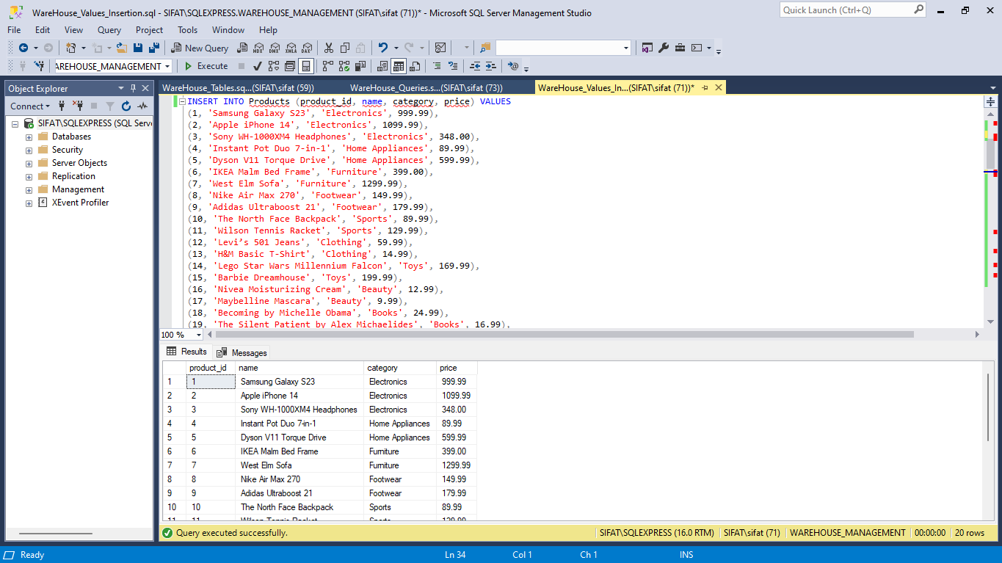**Table: Products**

**Table: Inventory**

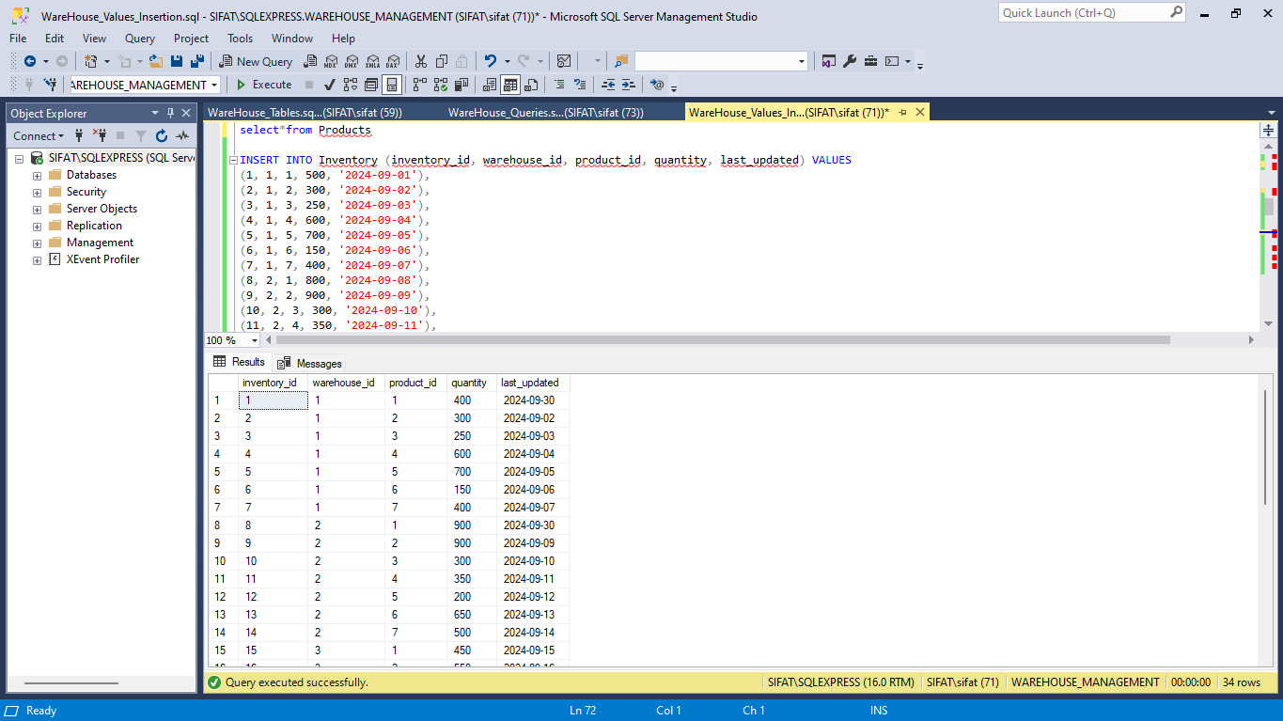

**Table: Transfers**

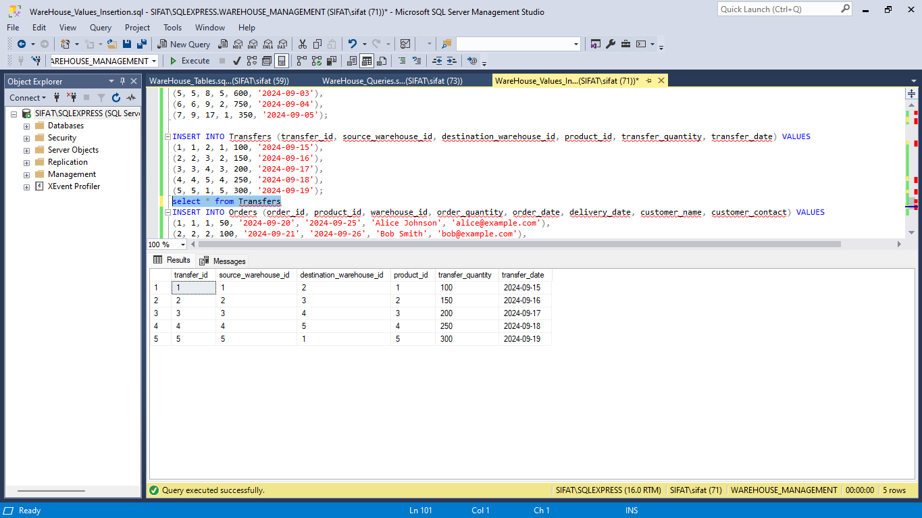

**Table: Suppliers**

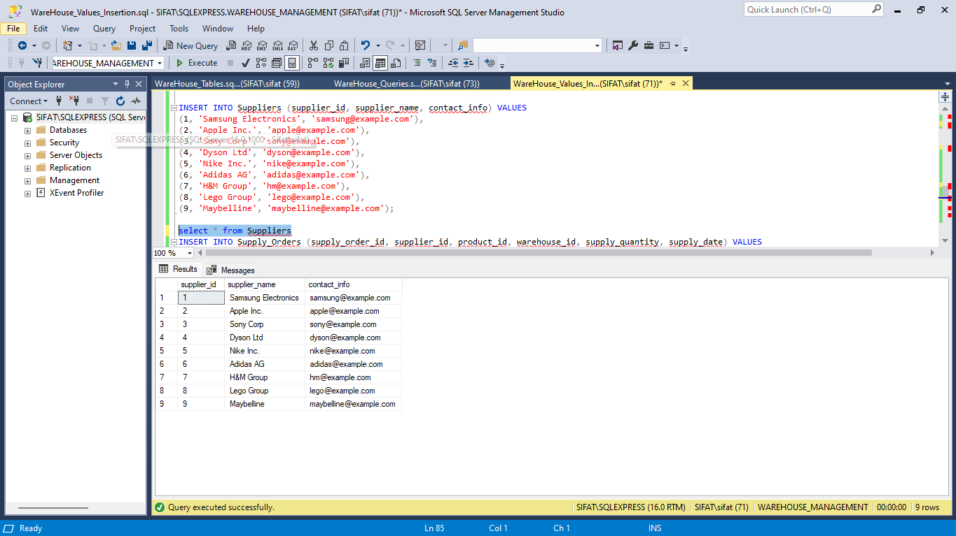

**Table: Orders**

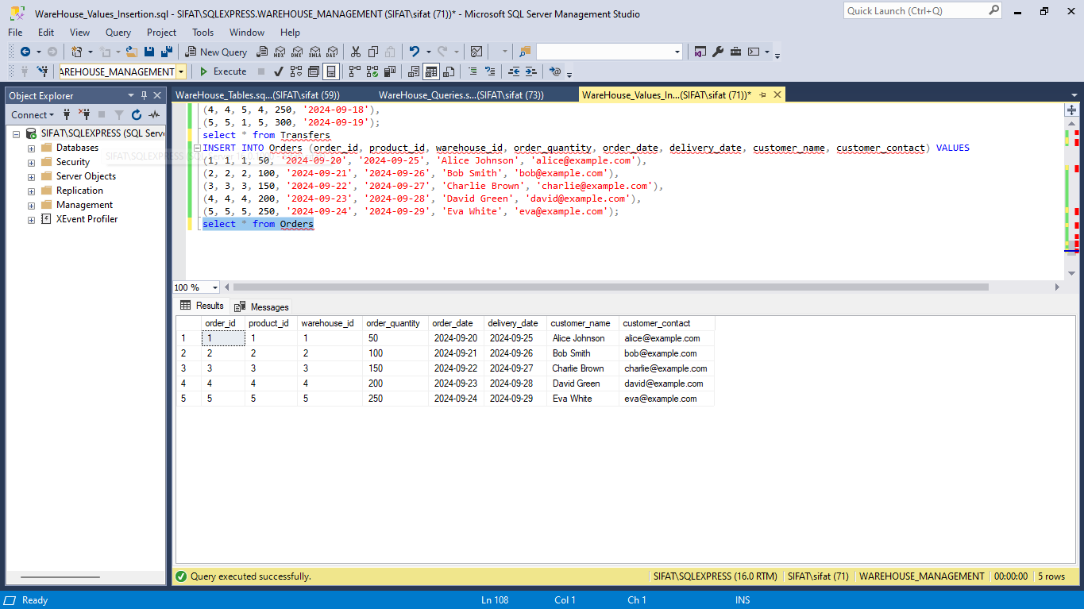

**Table: Suppy Orders:**

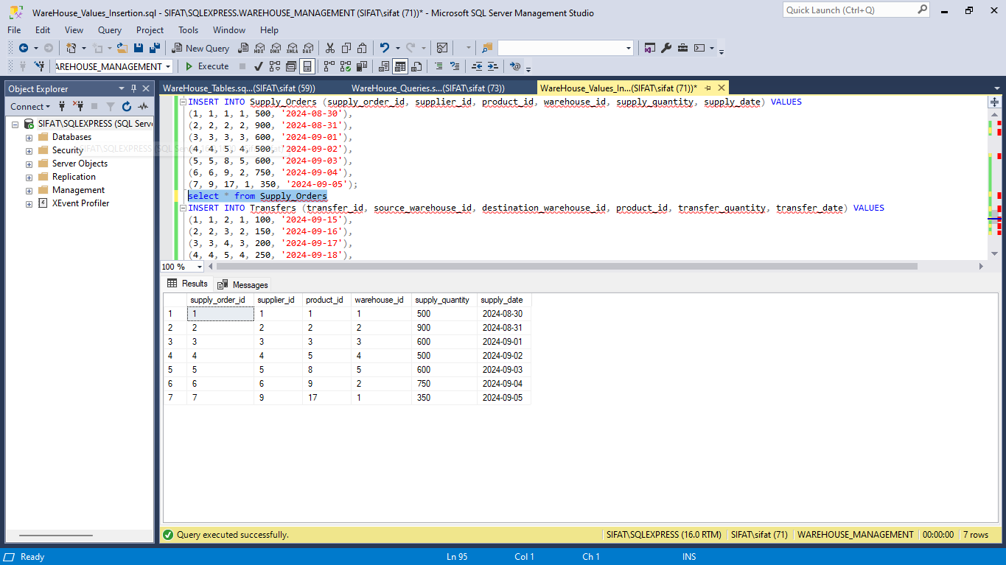

**Running Query:**

1. 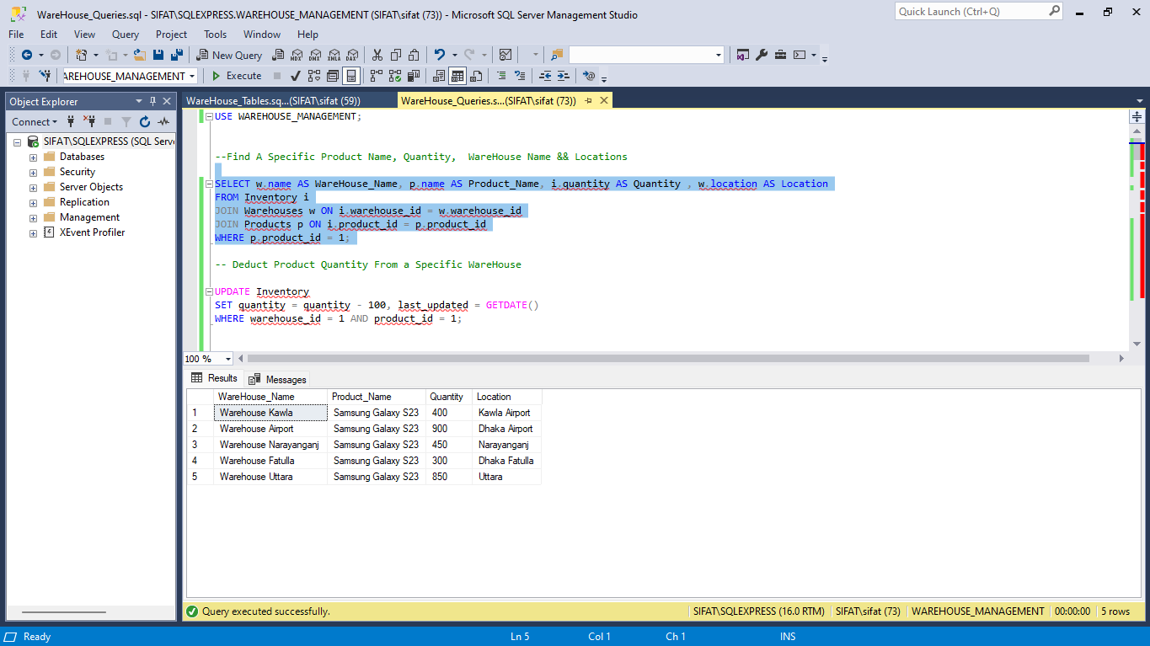Find A Specific Product Name, Quantity, WareHouse Name & Locations.
2. 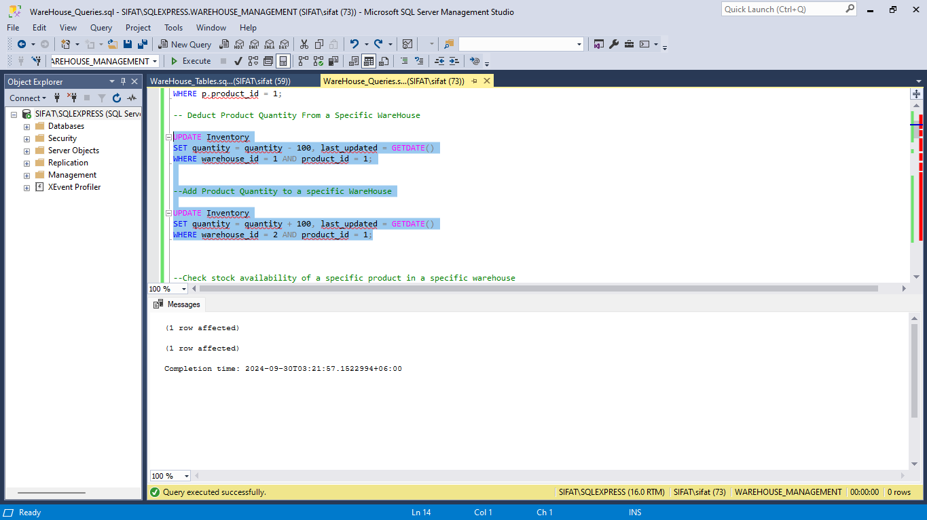Deduct & Add Product Quantity From a Specific WareHouse
3. Check stock availability of a specific product in a specific warehouse

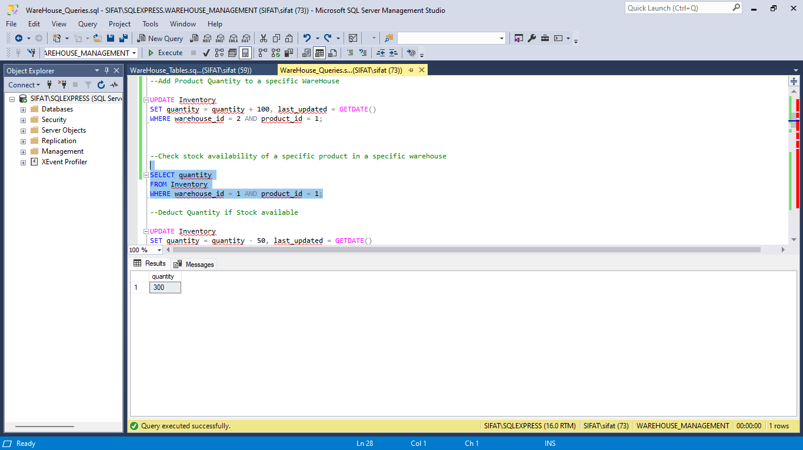

4.Stock Level Report.

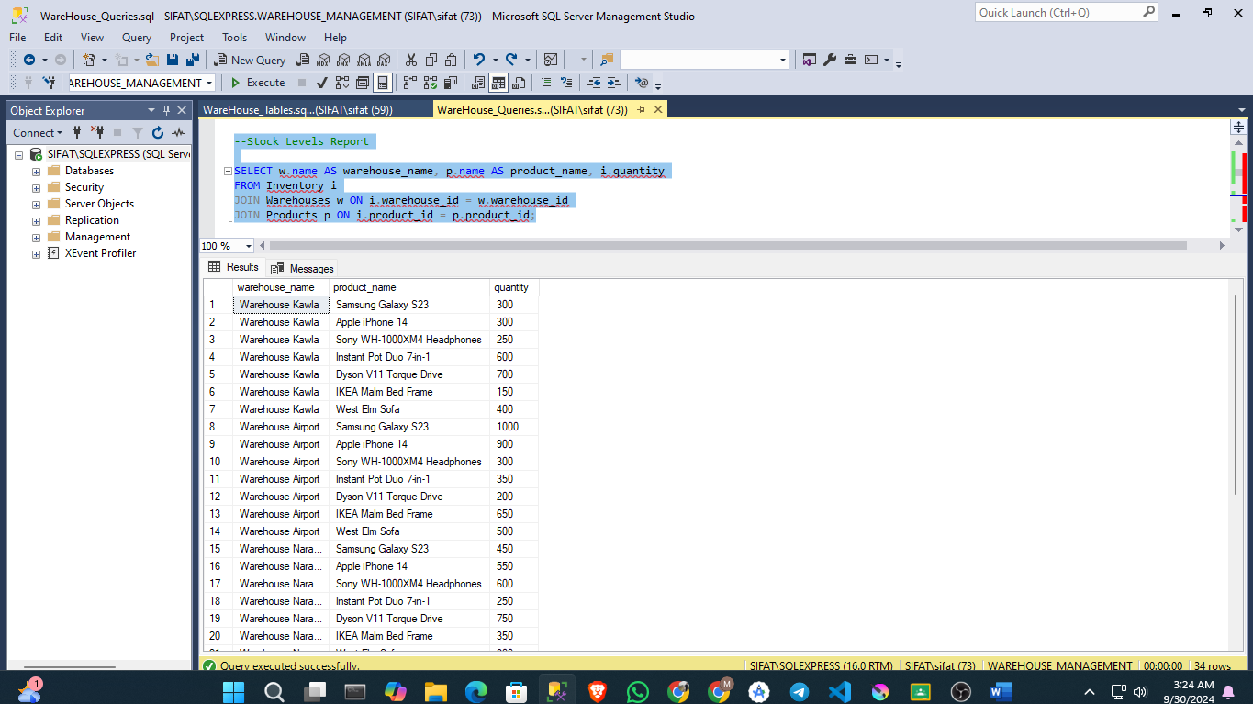

5.Product Transformation History & Fulfillment Report.

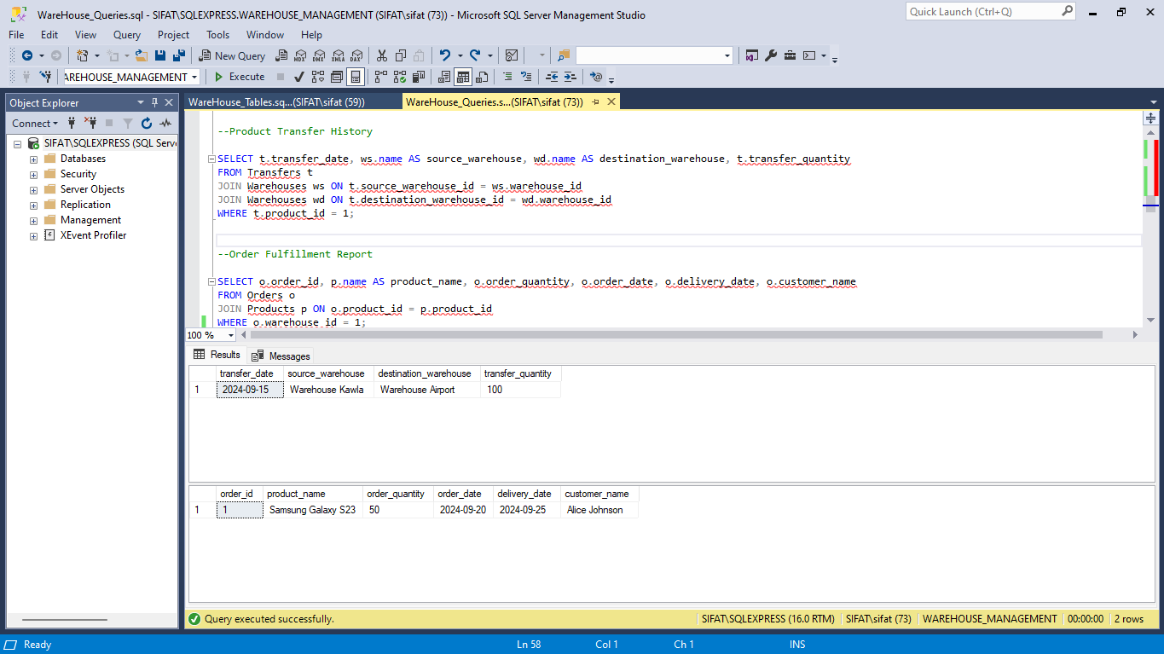

7.Find suppliers for a specific product & Find products supplied to a specific warehouse by a specific supplier.

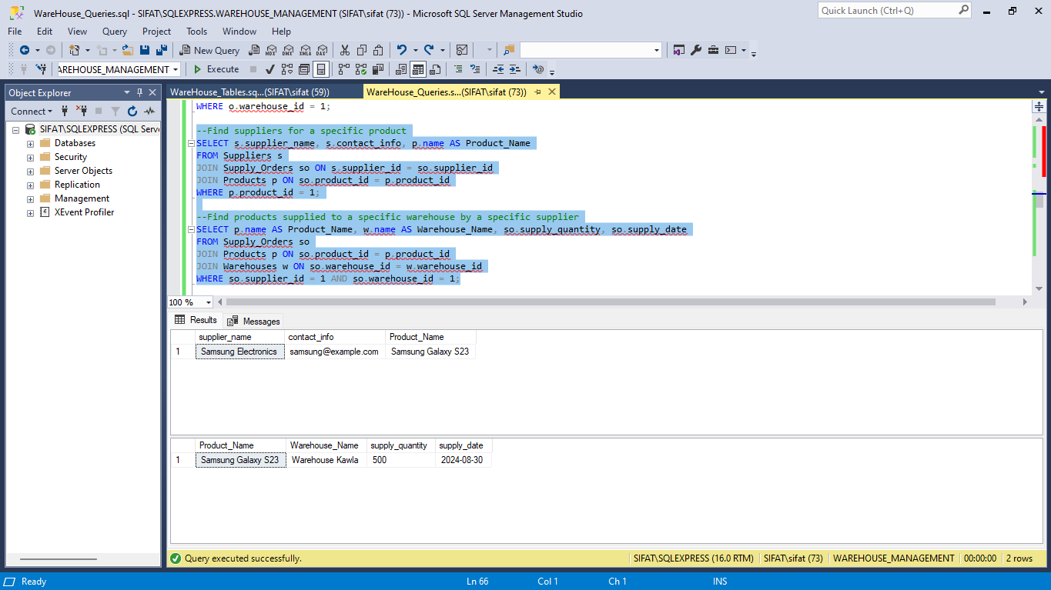

8. Report products with low stock in any warehouse & Find top-selling products based on order quantity

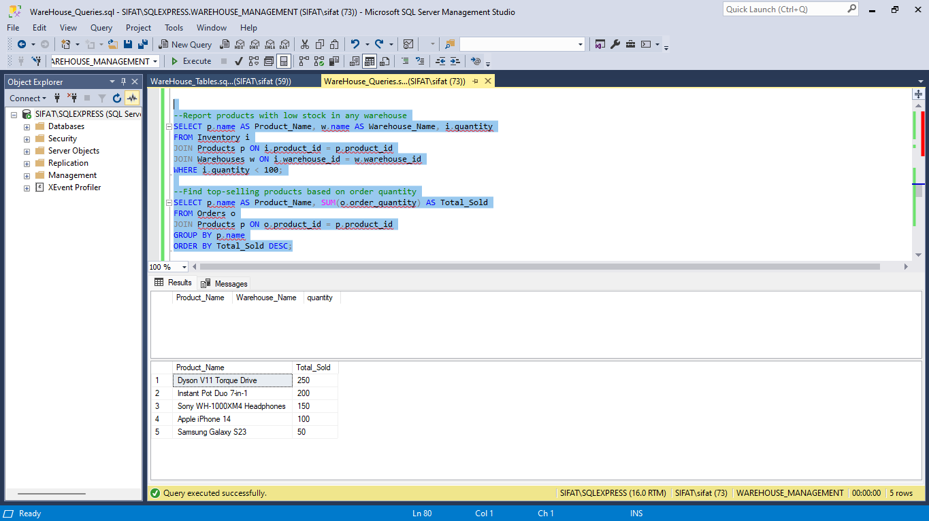

9. Find product transfer history between specific dates

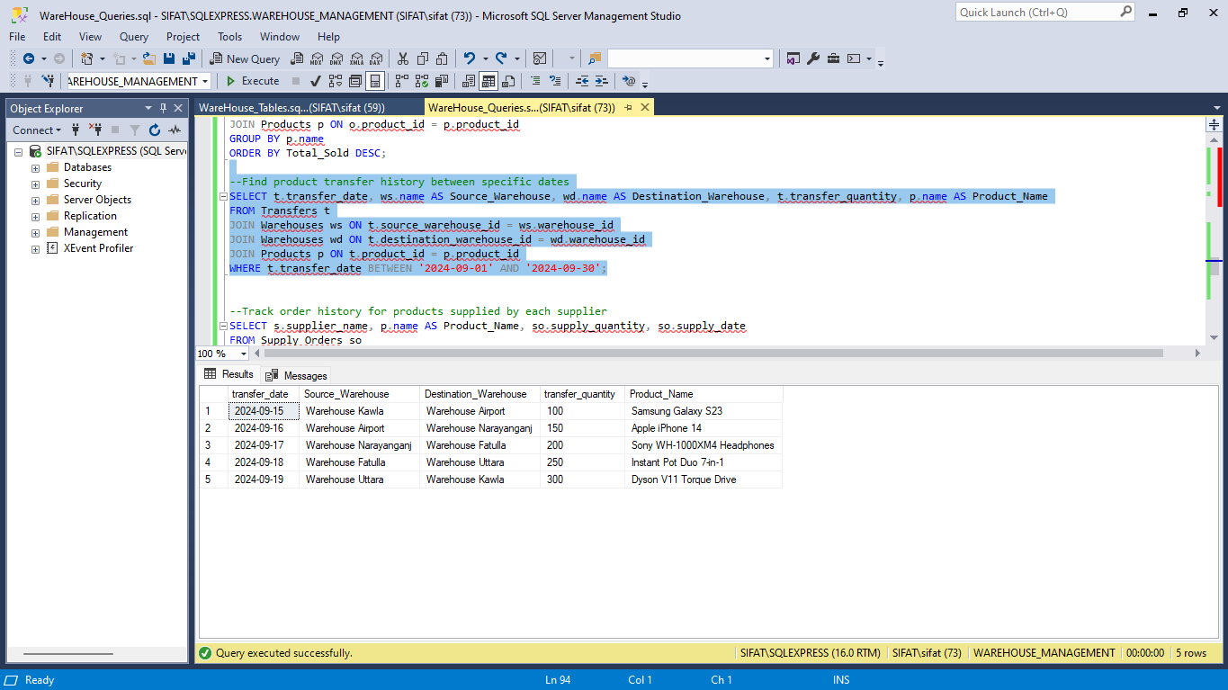

10. Track order history for products supplied by each supplier

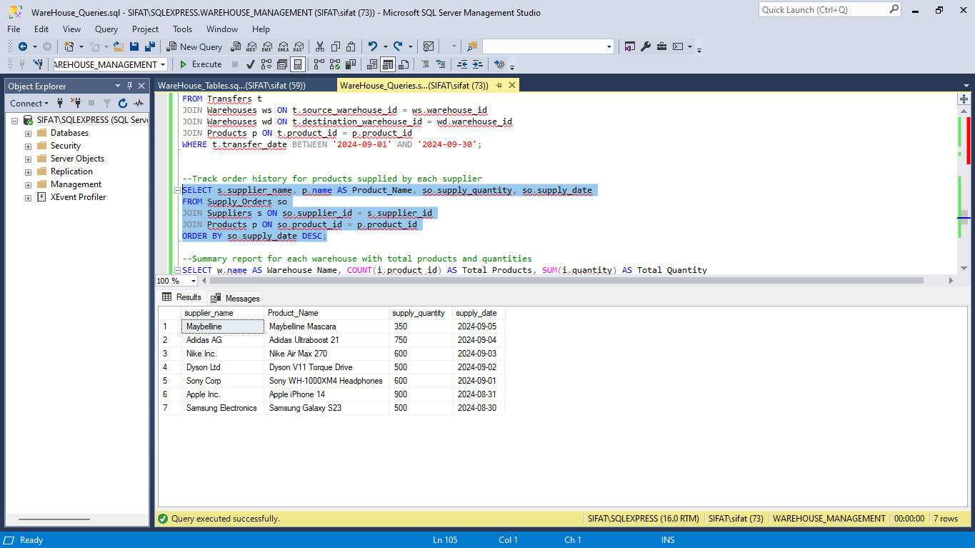

11. Summary report for each warehouse with total products and quantities & Calculate total value of products in each warehouse

